Free Youtube views for an unlimited number of your videos! Boost your video's popularity using their simple and free method! Or, buy Youtube views and other services here.

[ythunder.com](https://ythunder.com/) has free & open registrations.

At YTHunder, we offer a variety of amazing services to help you simplify success, but with new social media features being added on a regular basis - and new types of URLs - sometimes ordering a service can be confusing. That’s why we’ve created an in-depth guide to extracting the links that Free Youtube views：[ythunder.com](https://ythunder.com/)

you need to place your orders quickly, efficiently, and successfully.

***While we update our guide regularly, our services frequently change and the examples below may not always be available for purchase.***

**[YouTube Views](https://ythunder.com/), Likes, Shares, & Comments**Free Youtube views：[ythunder.com](https://ythunder.com/)

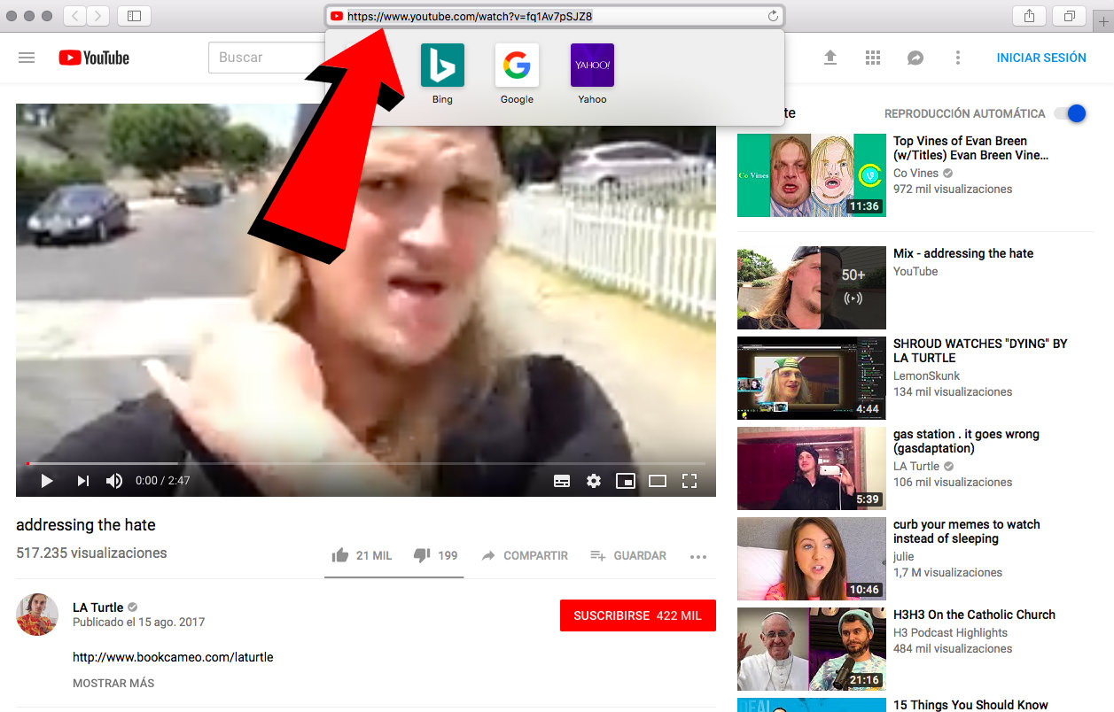

To order [YouTube Views](https://ythunder.com/) and Likes, provide your [YouTube](https://ythunder.com/) video URL by visiting the video page and selecting the URL text in the navigation bar. Your link should have one of the following formats:

https://www.[youtube](https://ythunder.com/).com/watch?v=fq1Av7pSJZ8

https://youtu.be/l1gY9Cwt6TM

https://www.[youtube](https://ythunder.com/).com/watch?v=l1gY9Cwt6TM&feature=youtu.be

**[YouTube](https://ythunder.com/) Comment Likes**

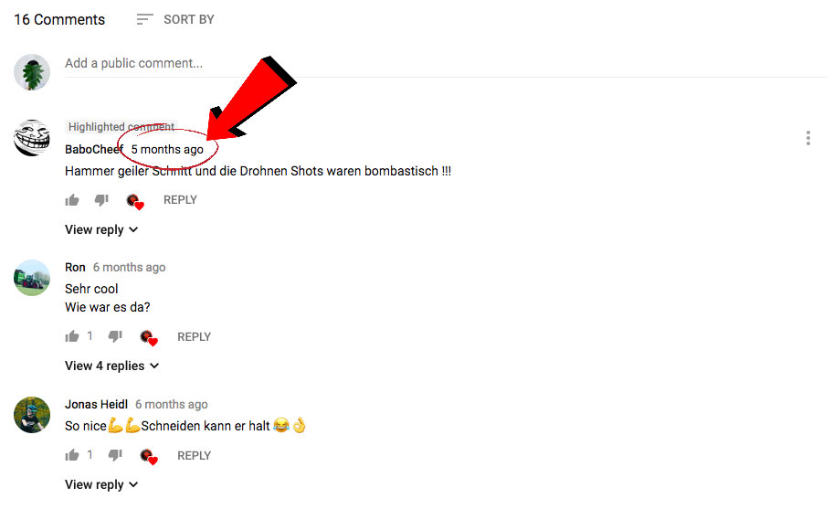

For our [YouTube](https://ythunder.com/) Comment Likes service, the unique comment URL is required. To find this, right-click the posting date to the right of the commenter’s username and select “copy URL”. Your link should look like the following example:

https://www.[youtube](https://ythunder.com/).com/watch?v=exLTcPYLVHQ&lc=UgyeV-DIGFfiPxBUaDB4AaABAg

If you are purchasing comment likes for a comment made on your own video, please log out of the [YouTube](https://ythunder.com/) account that posted the comment, and check to see if you are still able to view the comment with the URL provided. If not, the comment may need to be approved by the owner of the video before the comment is made public. We cannot deliver to comments that have not yet been made public.

Please note that we cannot process Comment Likes orders for a Sub-Comment. Unfortunately, we are unable to successfully deliver likes to a comment that is a reply to another comment.

**[YouTube Subscribers](https://ythunder.com/)**

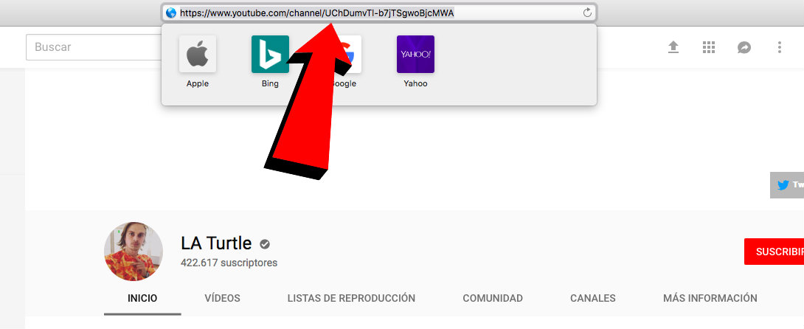

Subscriber orders should be formatted as such:

http://www.[youtube](https://ythunder.com/).com/channel/UCasdjhflkasdjhf

The string of characters after the "channel/" is unique to your channel and necessary for our system to direct subscribers to you.

You can find this by going to one of the videos on the channel and then clicking on the channel name. Your URL bar will now have the correct URL.

**DailyMotion Views**

To order Dailymotion views, provide your Dailymotion video URL by visiting your video on Dailymotion.com and selecting the URL in the navigation bar. Your link should have the following format:

https://dailymotion.com/video/abcdef

Please note: Dailymotion Views should be purchased for a Dailymotion video with a Dailymotion video URL. We can not process Dailymotion Views with a [YouTube](https://ythunder.com/) URL.

**Vimeo Views & Likes**

To order Vimeo views, provide your Vimeo video URL by visiting your video on vimeo.com and selecting the URL in the navigation bar. Your link should have the following format:

https://vimeo.com/12345678

Please note: Vimeo Views should be purchased for a Vimeo video with a Vimeo video URL. We can not process Vimeo Views with a [YouTube](https://ythunder.com/) URL.

**Twitch Livestream VIEWS**

To order Twitch Livestream views, provide your Twitch video URL by visiting your stream on twitch.tv and selecting the URL in the navigation bar. Your link should have the following format:

https://twitch.tv/abcdef

Please note: Twitch Livestream Views should be purchased for a Twitch video with a Twitch video URL. We can not process Twitch Livestream Views with a [YouTube](https://ythunder.com/) URL.

**TikTok Views**

To order TikTok views, provide your TikTok video URL by visiting your video on the tiktok.com and selecting the URL in the navigation bar. Your link should have the following format:

https://vm.tiktok.com/RMaJ43

**DO NOT input links in the following format:**

https://vm.tiktok.com/@hasshammoud2

Our order system will NOT deliver to links with this format. Please ensure that you have selected the correct format before placing your order, as our services cannot be delivered to incorrect URLs.

**Spotify Plays**

To receive Spotify Plays, you’ll need the URL unique to the track you want Plays for. Please keep in mind that our service is for individual tracks, not entire albums. To find the correct track URL, select the three stacked dots to the right of your track name. Your track URL should look like this: https://open.spotify.com/track/7Jh1bpe76CNTCgdgAdBw4Z?si=rNbF2A-RRmm7Ltjfy7Io9w

**Note: Your URL should contain the word “track”. If your URL contains the word “album” you will not be able to place an order for Spotify Plays.

**Spotify Followers**

To receive Followers, you’ll need the URL that leads to your Spotify Artist profile. Select the three dots below the artist’s name and select “Share”. From there, select “Copy Artist Link”. Your URL should look something like this example:

https://open.spotify.com/artist/0oSGxfWSnnOXhD2fKuz2Gy?si=-S7HFmKMTEKFXREziX-K8A

**Spotify Playlist Followers**

To order Playlist Followers, visit the playlist that you want to order followers for and select the three dots next to the heart icon. From there, select “Share”, and “Copy Playlist Link”. Your URL should look something like this example:

https://open.spotify.com/user/spotify/playlist/37i9dQZF1DWTTthpScXd3v?si=wL3I7lDgTICg6gFg9Tk2wQ

**Soundcloud Plays**

To order SoundCloud Plays you’ll need the URL that leads directly to your track. To find this, visit your track and select the URL from the navigation bar. It should look something like this:

https://soundcloud.com/siennechambers/re-establish

**Pinterest Account Followers**

To receive Pinterest Account Followers, you’ll need to copy the URL that leads to your profile. You can either visit your Pinterest profile online and select the URL in the navigation bar, or replace the example username with your own username:

*https://www.pinterest.com/EXAMPLE*

**Pinterest Board Followers**

Our Pinterest Board Followers service requires the URL that leads to the board you want to receive followers on. Simply visit your board and select the URL in the navigation bar. It should look something like this:

*https://www.pinterest.com/SocialPromoterMarketing/*[*youtube*](https://ythunder.com/)

**Pinterest Repins**

For our Repins service, you’ll need to copy the URL unique to your Pin. Visit the Pin and copy the URL in the navigation bar. It should look similar to this example:

*https://www.pinterest.com/pin/779193173006136442*

**Instagram Mentions**

For all of our Instagram Mentions services, you will require two pieces of information - the hashtag, username, or post that you would like to get your list of users from, and the post URL that you would like your these users to be mentioned in.

The simplest way to find your post URL this is by visiting the post through Instagram’s desktop site and copying the URL in the navigation bar. To find the URL on the mobile app, open the post you want and select the three stacked dots in the top right corner. From there, select Copy Link to retrieve the necessary URL. It should look similar to this example:

https://www.instagram.com/p/Bolg0Bin1GP/

For information on each variation of our Instagram Mentions service, please see the examples below:

**[Hashtag]**

Input a hashtag of your choice and our Instagram Mentions service will curate a list of users that follow the hashtag, mentioning them in your post.

Example: #icecream

**[User Followers]**

Input a username and our Instagram Mentions service will mention the user’s follower list on your post.

Example: @gainrank

**[Likes]**

Input a post URL (different from the one you want the users to be mentioned on) and our Instagram Mentions service will create a curated list of followers that have liked the post, and will mention them in your post. It should look similar to this example:

https://www.instagram.com/p/Bolg0Bin1GP/

**Instagram Saves, Likes, Custom Comments, & Views**

For our Instagram Saves, Likes, Custom Comments, and Views services, all you need is the URL to the post you want to place an order for. The simplest way to find this is by visiting the post through Instagram’s desktop site and copying the URL in the navigation bar. To find the URL on the mobile app, open the post you want and select the three stacked dots in the top right corner. From there, select Copy Link to retrieve the necessary URL. It should look similar to this example:

https://www.instagram.com/p/Bolg0Bin1GP/

**Instagram Followers**

Our Instagram Followers service requires you to submit the URL to the Instagram Profile that you want to gain followers on. Simply replace the following EXAMPLE text with your own username: https://www.instagram.com/EXAMPLE/

**Facebook Profile Followers**

Our Facebook Profile followers service requires you to submit the URL to the Facebook Profile that you want to fain followers on. Simply replace the following EXAMPLE text with your own profile username:

https://www.facebook.com/EXAMPLE

**Facebook Page Post Likes & Facebook Post Shares**

For our Facebook Page Post Likes and Facebook Post Shares services, you’ll need the URL that leads directly to the post you want to order likes or shares for. Select the three dots on the top right of the post you want to order likes for and select “Embed”. From there, click “Advanced Settings”, and your URL should appear on the top left. It should look something like this:

https://facebook.com/abcdef.123456/abcde/987654

**Facebook Video Views**

For our Facebook Video Views service simply select the URL of the video you would like to receive Views for.

Your URL should look something like this:

https://www.facebook.com/abcdef/videos/123456

**Facebook Page Likes**

For our Facebook Page Likes service, simply select the URL of the page you would like to receive Likes on. Your URL should look something like this:

https://www.facebook.com/SocialPromoterMarketing

**Mixcloud Plays**

To order Mixcloud plays provide your Mixcloud track URL by visiting your upload on mixcloud.com and selecting the URL in the navigation bar. Your link should have the following format:

https://mixcloud.com/abcdef/ghifjk

**Mixcloud Reposts**

To order Mixcloud reposts provide your Mixcloud track URL by visiting your upload on mixcloud.com and selecting the URL in the navigation bar. Your link should have the following format:

https://mixcloud.com/abcdef/ghifjk

**Mixcloud Followers**

To order Mixcloud Likes, provide your Mixcloud artist profile URL by visiting your profile on mixcloud.com and selecting the URL in the navigation bar. Your link should have the following format:

https://mixcloud.com/abcdef

**Mixcloud Comments**

To order Mixcloud Comments provide your Mixcloud track URL by visiting your upload on mixcloud.com and selecting the URL in the navigation bar. Your link should have the following format:

https://mixcloud.com/abcdef/ghifjk

**Mixcloud Likes**

To order Mixcloud Likes provide your Mixcloud track URL by visiting your upload on mixcloud.com and selecting the URL in the navigation bar. Your link should have the following format:

https://mixcloud.com/abcdef/ghifjk

**Reddit Upvotes**

To order Reddit Upvotes provide your Reddit comment URL by visiting your comment on reddit.com. Right-click the posting time (i.e “2 hours ago”, “1 day ago”) and select “Copy Link Address”. Your link should have the following format:

https://www.reddit.com/r/abc/comments/def/ghi

**Experiencing an issue or need information that isn’t provided here? Open a support ticket and one of our Online Support Specialists will assist you right away!**

Free Youtube views for an unlimited number of your videos! Boost your video's popularity using their simple and free method! Or, buy Youtube views and other services here.

[ythunder.com](https://ythunder.com/) has free & open registrations.